6. React-JS HOL

Name:- Shubham Sangram Bej

Hands-on 6

Objective
- Understand React Routing using React Router.
- Navigate between multiple components without refreshing the page.
- Pass URL parameters using useParams().
- Display trainer details using React components.

Software Requirements
- Node.js
- npm
- React
- React Router DOM
- Visual Studio Code

Project Name
trainersapp

Procedure
- Created a new React application named trainersapp.
- Installed react-router-dom package.
- Created a Trainer model class.
- Created a TrainersMock.js file containing trainer information.
- Created the following components:
  - Home
  - TrainersList
  - TrainerDetails
- Configured routing using:
  - BrowserRouter
  - Routes
  - Route
  - Link
- Used useParams() to retrieve the trainer id from the URL.
- Displayed trainer details dynamically based on the selected trainer.
- Executed the application using:
npm start
- Verified navigation between all pages.

Output
The application successfully displays:
- Home Page
- Trainers List
- Trainer Details
Navigation is performed without refreshing the browser using React Router.
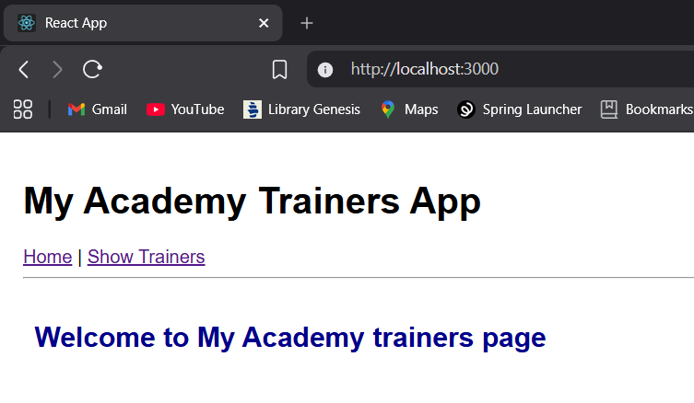
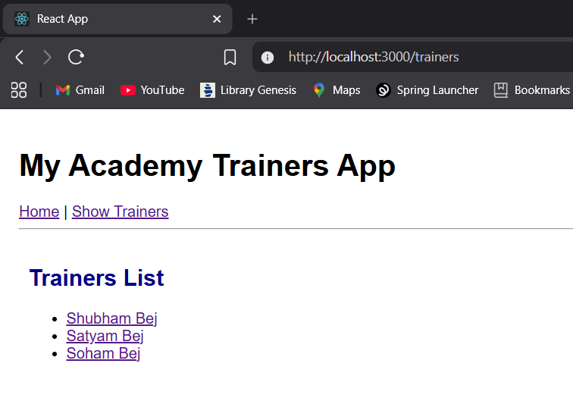
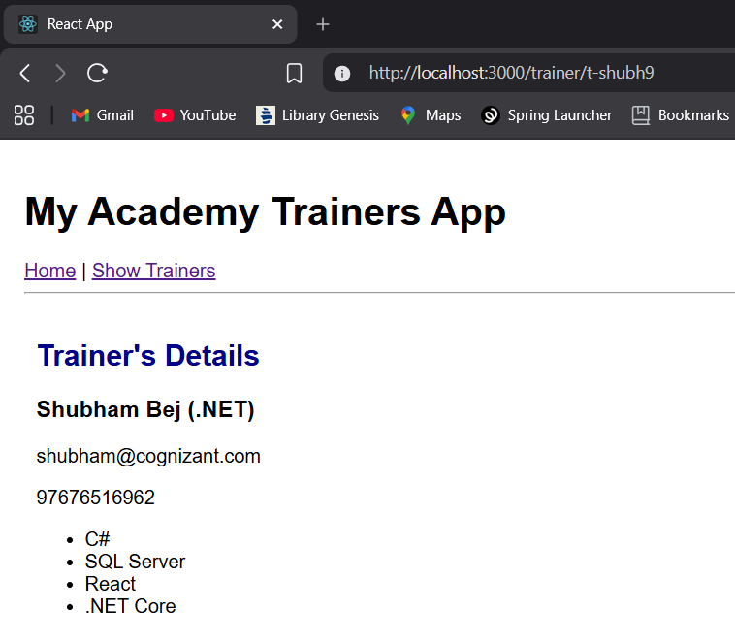

Result
The React application trainersapp was successfully developed using React Router. Dynamic routing and URL parameter handling were implemented successfully.

